James Jordan
EC 231
Microeconomics

Provide brief essay answers. Use mathematical formulas, notations, or graphs where necessary.

- What are the four factors of production? The four factors are land, labor, capital and entrepreneurship.

- What are they used for? They are the resources used in creating and producing a good or service and are the building blocks of an economy.

- Give a non-land example of the land factor of production that is not in your book. An example is eggs and butter used to make a cake.

- Why is a fixed input considered fixed? The level of usage cannot be readily changed must be paid even if no output is produced.

- Give an example of a fixed input that is not in your book. An example would be the house used when making the cake.

- Provide a mathematical view of a production function. Q=f[NR,L,K,t,E]

- What is the difference between the short run and the long run? Short run is the period of time during which at least some factors of production are fixed. Long run is the period of time during which all factors are variable.

- What is the one component that makes a production run short? The one component that makes a production run short is marginal product.

- What makes a production run long? The more variables are what makes a production long. All factors being variables shows the most efficient way of producing any level of output.

- Provide a complete graph that shows the relationship between the production function
and the marginal product.
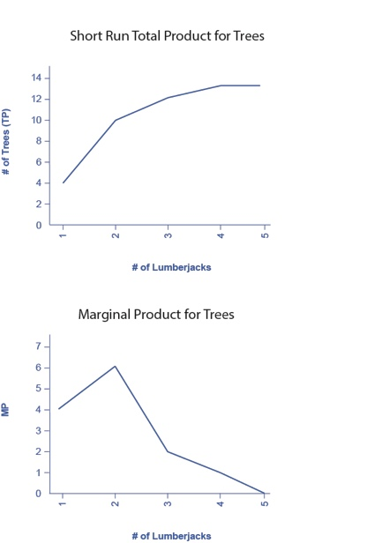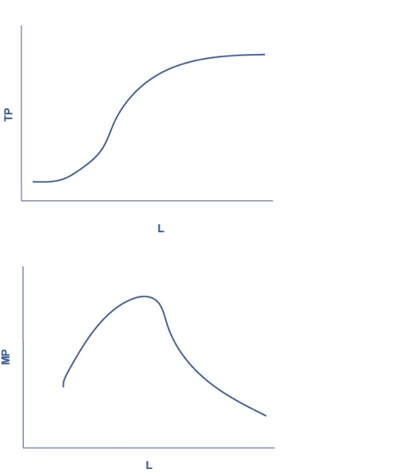

- What is the Law of Diminishing Marginal Product (DMP)? The marginal product increases at first, but sooner or later there will be a decreasing marginal product. There may be a negative effect or no effect on output.

- Provide a graph of that shows the (DMP) phase of a production function 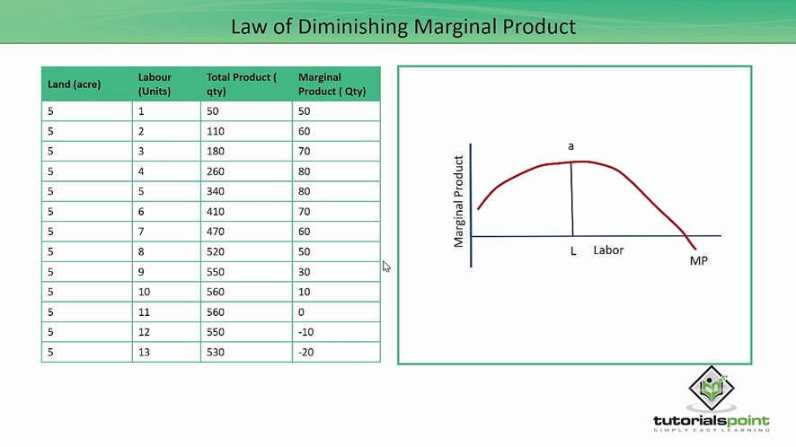
- What is the connection between variable input, fixed input, and DMP? Fixed input are variables are those that can't easily be increased or decreased in a short period of time. Variable input those that can easily be increased or decreased in a short period of time. The connection between the three are that variable input and fixed input determine whether or not the DMP will apply.

- What is a variable input? Variable input those that can easily be increased or decreased in a short period of time.
- What does this input vary? One can change easily and the other cannot change.
- Provide an example of a variable input that is not in your book. The ingredients in a cake.

Completely answer all of the questions, but please keep your answers as brief as possible. Please type all answers. If you are not able to type your answers, hand write them neatly. I will take points off for sloppy work. Also, make sure your answers are legible. If I cannot read your answers I cannot grade your papers. When you complete this assignment, place in Drop Box 6.

