Lab 2: Projectile Motion
PHYS 213L 01
Betelhem Shefnie
Date: 8/31/2020

Brief Theory:
Projectile motion is the motion of an object thrown or projected into the air, subject only to acceleration as a result of gravity. Once an object is in the air, its path is governed by factors prior to its release. Some of the factors include speed, angle, gravity, the height of release, and air resistance, The applications of projectile motion in physics and engineering are numerous. Some examples include meteors as they enter Earth’s atmosphere, fireworks, and the motion of any ball in sports. Such objects are called projectiles and their path is called a trajectory.
Data Presentation:

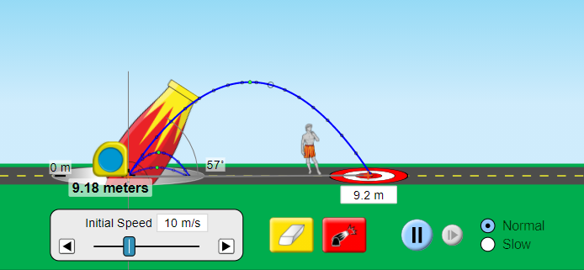
Figure 1.1: The image shows the simulation for an object thrown at y=0. The initial values are the speed at 10m/s, and the angle at 57 degrees. The calculation below shows that the simulation is right.

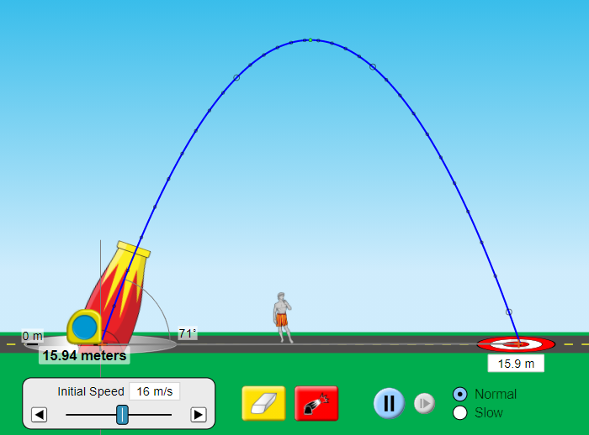
Figure 1.2: The image shows the simulation for an object thrown at y=0. The initial values are the speed at 16m/s and the angle at 71 degrees. The calculation below shows that the simulation is right.
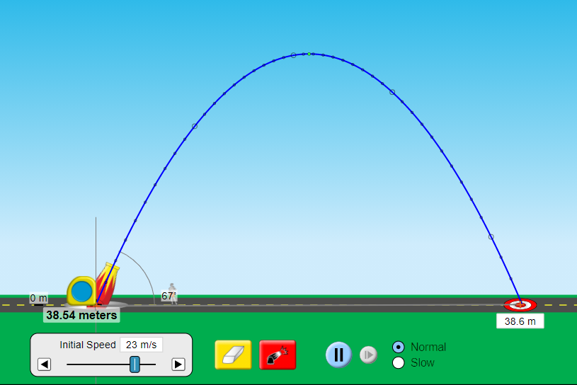
Figure 1.3: The image shows the simulation for an object thrown at y=0. The initial values are the speed at 23m/s and the angle at 67 degrees. The calculation below shows that the simulation is right.

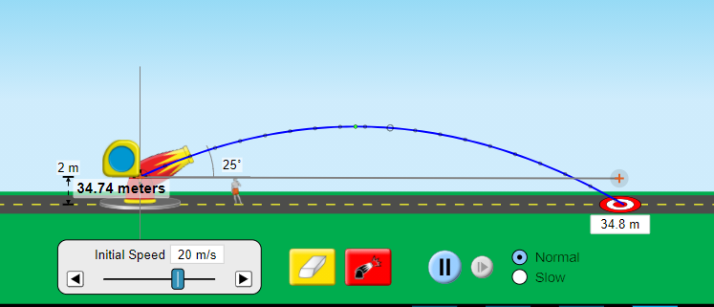
Figure 2.1: The image shows the simulation for an object thrown at y=2. The initial values are the speed at 20m/s and the angle at 25 degrees. The calculation below shows that the simulation is right.

Calculations:
- Hands-on calculation for the above simulations.
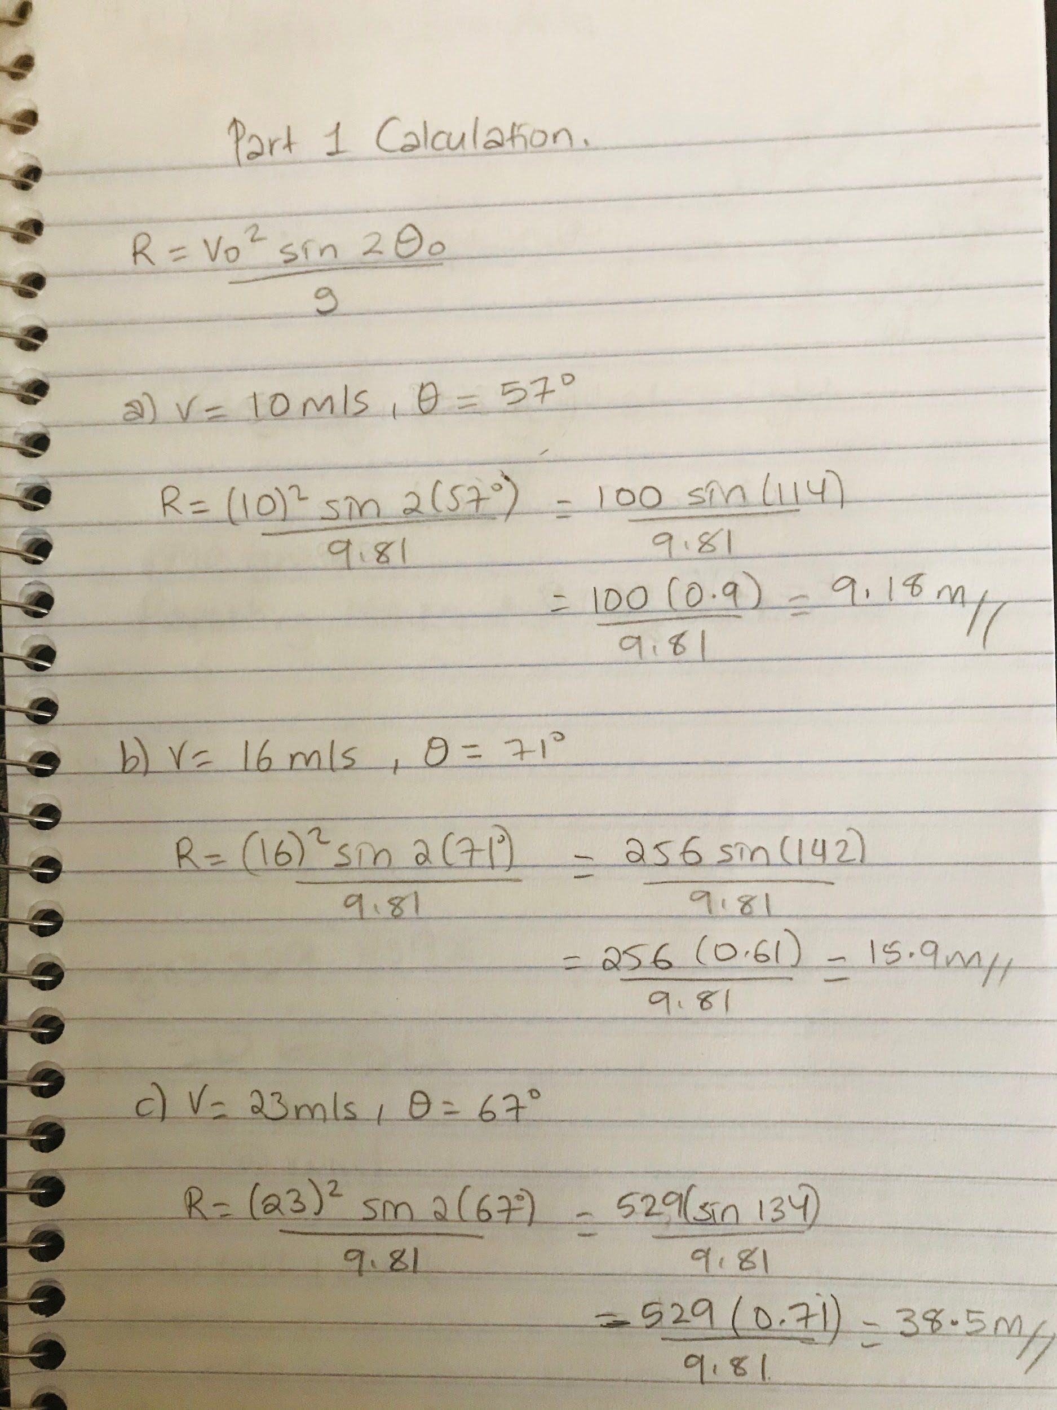
The calculation for Figures 1.1, 1.2, and 1.3.
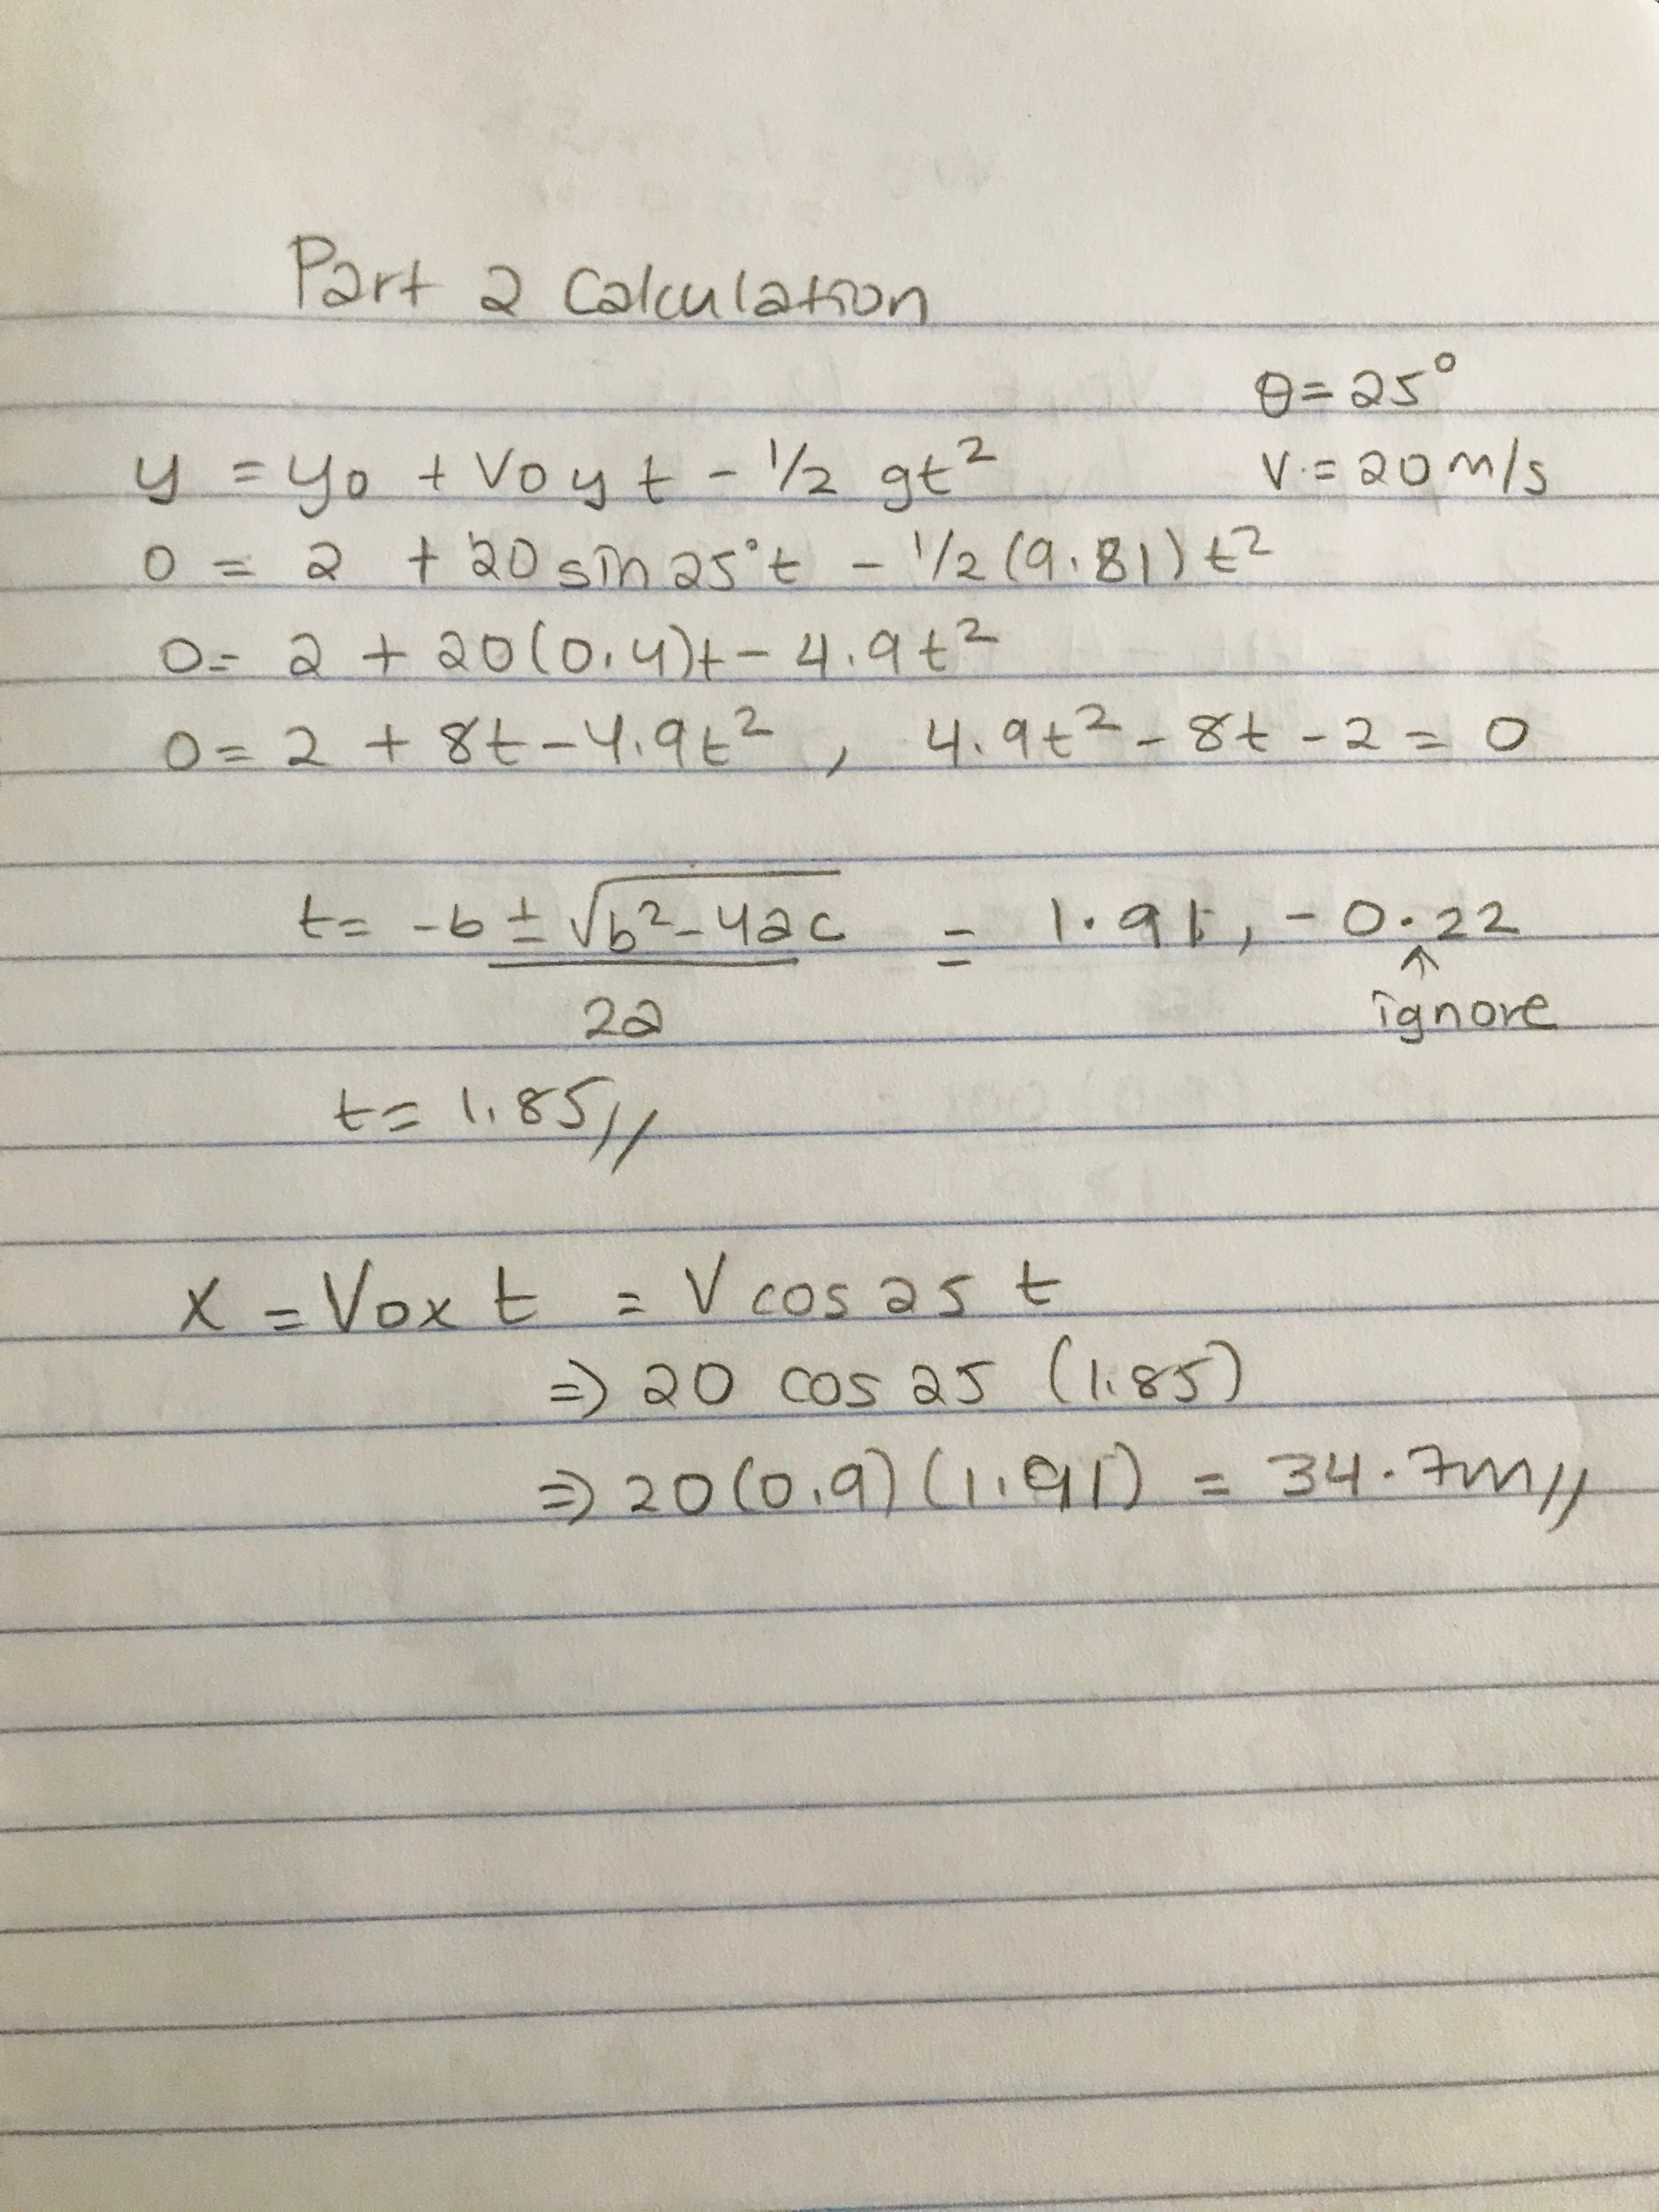
The calculation for Figures 2.1

Conclusion:
• Choose a variable and design an experiment to determine how it affects the projectile’s path.
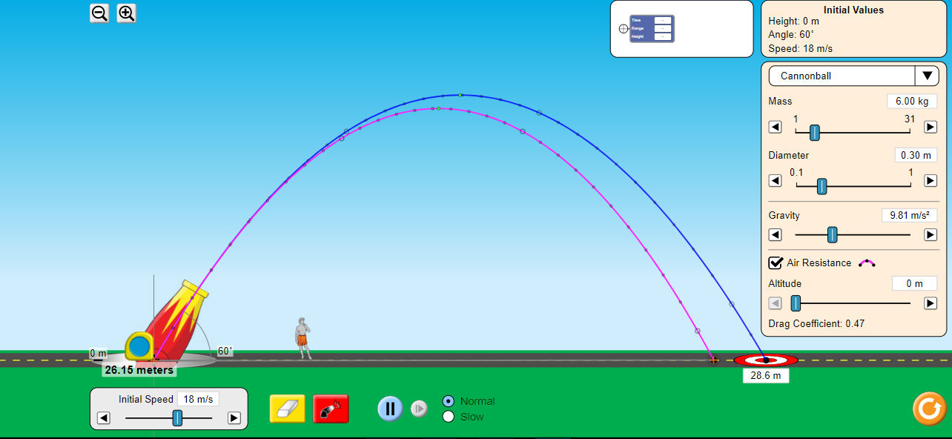
- According to the above figure, the only thing that changes was the air resistance. The mass and diameter don’t have any effect if the air resistance is off. But if it is on, any change in the mass or the diameter will change the path of the cannonball thrown.
• Predict how changing the initial conditions will affect the path of the projectile, and explain your reasoning.
- Speed refers to how fast the object is released. The greater the speed, the greater the distance.
- Angle - The lower the angle, the lower distance, and poor flight time.
- Height - how high above the ground the object is released at. For a given angle and speed, the greater the height, the greater the distance.
- Gravity - decreases the height a projectile can reach.

• Determine which factors affect the range of the projectile when air resistance is turned on, but have no effect when air resistance is turned off.
- The factors that affect the range of the projectile when the air resistance is on are mass and diameter of the ball. They don’t have any effect when the air resistance is off.

• Describe how the behavior of the velocity and acceleration vectors over time, and how they are affected by air resistance.
- If acceleration points in the same direction as the velocity, the object will be speeding up. And if the acceleration points in the opposite direction of the velocity, the object will be slowing down. When air resistance acts, acceleration during a fall will be less than g because air resistance affects the motion of the falling objects by slowing it down.

• Explain why the black dots on the projectile’s path are closer together near the top, but further apart when close to the ground.
- The Black dots are closer together near the top because the object is moving slower on the top. It has less acceleration on the top because the velocity of the object is similar at each point. When it goes apart when close to the ground, it shows that it is going in a fast speed although it is not accelerating but decelerating until it hits the ground.

• Create a situation in which the projectile reaches terminal velocity.
Terminal velocity is the maximum velocity attainable by an object as it falls through a fluid. Since the net force on the object is zero, the object has zero acceleration. A situation can be like a baseball or a golf ball being thrown. Air resistance plays an important role in that.

