PROFILE OF A REGION

STUDENT’S NAME: MICHAELA MURPHY

NAME OF THE REGION: RUSSIA________________________________________

- Please insert a map of the region below:

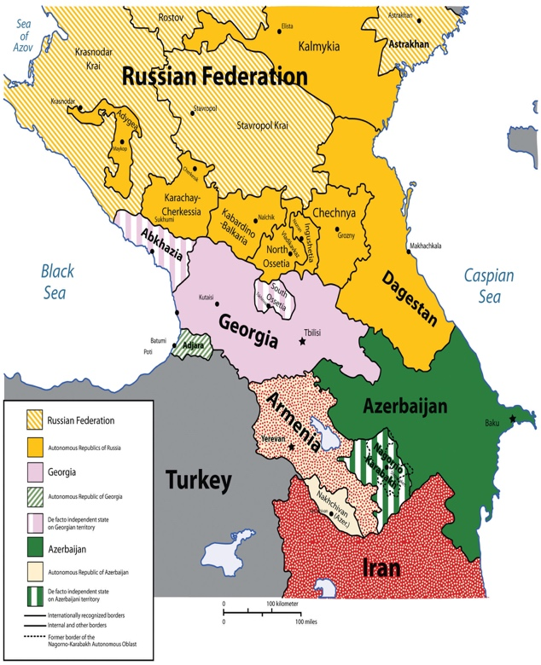
This Photo by Unknown Author is licensed under CC BY-SA-NC

- Please review the section of the textbook introducing the region, and summarize the location, the dominant climates, and the natural resources of the region in one or two paragraphs:

Russia extends its boundaries in Europe and Asia. The Asian side is bordered to the south and European side to the east. Russia is a northern country with most of its physical area above the latitude of 50 degrees north. The massive expanse of Russia exhibits a variety of physical environments, such as tundra’s, steppes, mountains, and birch forests. Type D (continental) climates dominate most of the country and characterize large landmasses such as Eurasia and North America. Russia has rich natural resources such as petroleum, natural gas, and forest products.

- Referring to the data available in the textbook and online (especially at the World Bank databank website at https://databank.worldbank.org/home.aspx), please discuss the level of development of the region in at least one paragraph:

The territory that makes up the Russian Federation was gradually conquered by the Russian Empire as the country expanded from its political core around Moscow/St. Petersburg during the 16th-19th centuries. The Czars ruled this empire by Russification. Russification refers to the attempt to minimize cultural differences and turn all Russian subjects into Russians. The Soviets took a different tack when it came to be taming the diversity of the empire. Vladimir Lenin, in 1917, and his supporters embarked on a quest to turn Russia into a Communist state. The post-Soviet transition to democracy and capitalism was filled with political, social and economic issues.

- Referring to the data available in the textbook and online (especially at the Freedom House website at: https://freedomhouse.org/), please discuss the level of democracy (or freedom) of the region in at least one paragraph:

This region has transitioned from so many different rules of power. From communism to socialism to capitalism. Communist ruling meant that there was no economic or social classes, no private property, not rich people, and no poor people. Most ethnic groups outside of Russians that fought for their independence as a community were not successful. Some were able to break free after the collapse of the Soviet Union after during the Cold War. A socialist state did not include open markets. The Soviet Union underestimated the power of capitalism which explains its failure.

