SCI 230e Isoelectric Focusing Assessment
Name Janae McCloud
Instructions: Analyze the figure below. For part A, give an estimate of the pH of each of the 3 samples. For part B, briefly explain, WHY each sample migrated in the direction shown and why it migrated the distance shown.
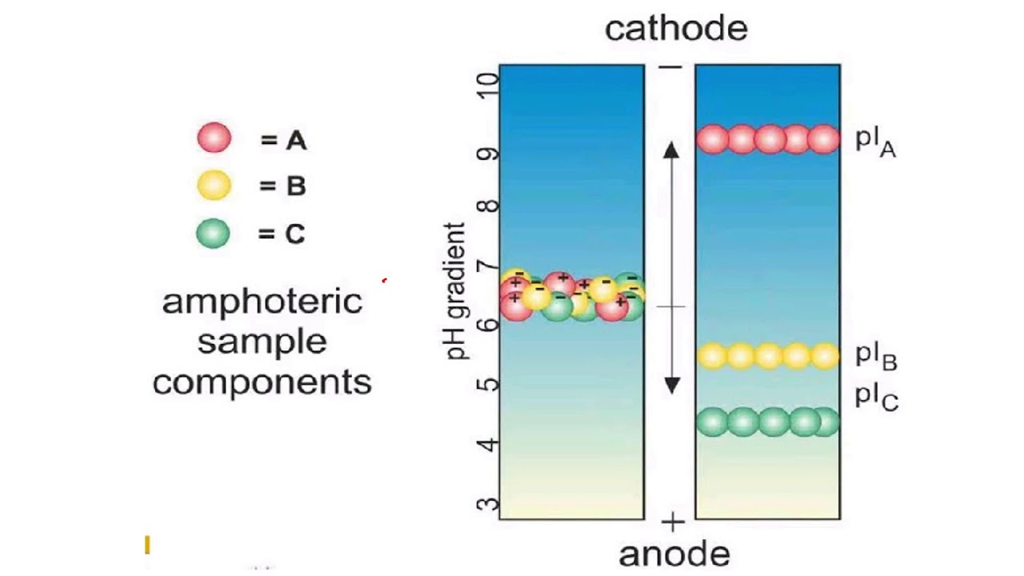

Part A: Estimated Ph of:
Sample A: 9
Sample B: 5.5
Sample C:4.4
Part B: Why did each migrate in a certain direction? And why did they migrate a certain
distance?
Sample A: It has a positive charge, so it migrated towards the cathode. It migrated to this point because it loses the necessary protons to gain a net charge of 0.
Sample B: It has a negative charge, so it migrated towards the anode. It migrated this distance, because it picked up the needed protos for a net charge of 0.
Sample C: It has a negative charge, so it moved towards the anode. It might\rated this distance because it gained the needed protons to obtain a net charge of 0.

