BIO 130 (General Biology)
Worksheet 2: The Origin of Life (CH. 19) (Total Points: 100)
Name: Shepperd, Ruby De’lite Date: 08/18/20
- A. State the concept of spontaneous generation. (5 pts)
Up until the 17th century a guy said life originated from nonlife and everyone believed him for over 2000 years.
B. Who proposed this concept? (5 pts)
Aristotle

- A. State the concept of Panspermia. (5pts)
A scientist hypothesized that life came from outside of earth being transported onto earth with no idea how life started.
B. Who proposed this concept? (5pts)
Svante Arrhenius

- Describe the concept of biogenesis. (10pts)
Life originated from other living things that came before

- Describe briefly the chemical evolution of life on earth. (10pts)
From 384-322b.c. life was thought to be created from non-life by Aristotle. After the 17th century life was then reconsidered to have come from being transported from outer space with no logical explanation on how it was created all together by Svante Arrhenius. Today is thought to be created from life that was here before. All in all, life was created by inorganic matter from uv rays from the sun resulting in life on earth.

Evaluate & draw Conclution:
Study Redi's Experiment and answer the following questions that follow.
Redi's Experiment
In 1668, Francesco Redi, an Italian physician, performed an experiment that challenged the concept of spontaneous generation. He set up a controlled experiment to test the hypothesis that maggots arose spontaneously from rotting meat (figure 19.1). He used two sets of jars that were identical except for one aspect. Both sets of jars contained decaying meat, and both were exposed to the atmosphere. However, one set of jars was covered by gauze while the other was uncovered. Redi observed that flies settled on the meat in the open jars, but the gauze blocked their access to the meat in the covered jars. He found that maggots appeared on the meat in the uncovered jars but not on the meat in the covered ones.
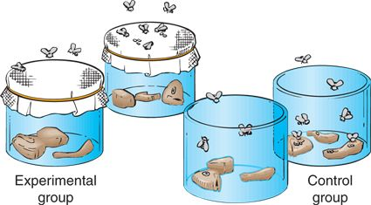
Questions from Redi’s experiment

- What hypothesis was Redi testing? (State the hypothesis in question form) (10pts)
Do maggots form from rotting meat?

- Were both groups (experimental & control) exposed to air? (10pts)
Yes

- What was the variable? (10pts)
The rotting meat
- Where did the maggots come from in the control group? (10pts)
The flies that surrounded it laying larva

- Did Redi’s experiment support spontaneous generation? (10pts)

No

- Which concept did this experiment support? (10pts)
Redi’s experiment went more along with the concept of biogenesis with the flies being the pre-existing life

