Keith Heyward Jr.
09212012
C++ lab 4

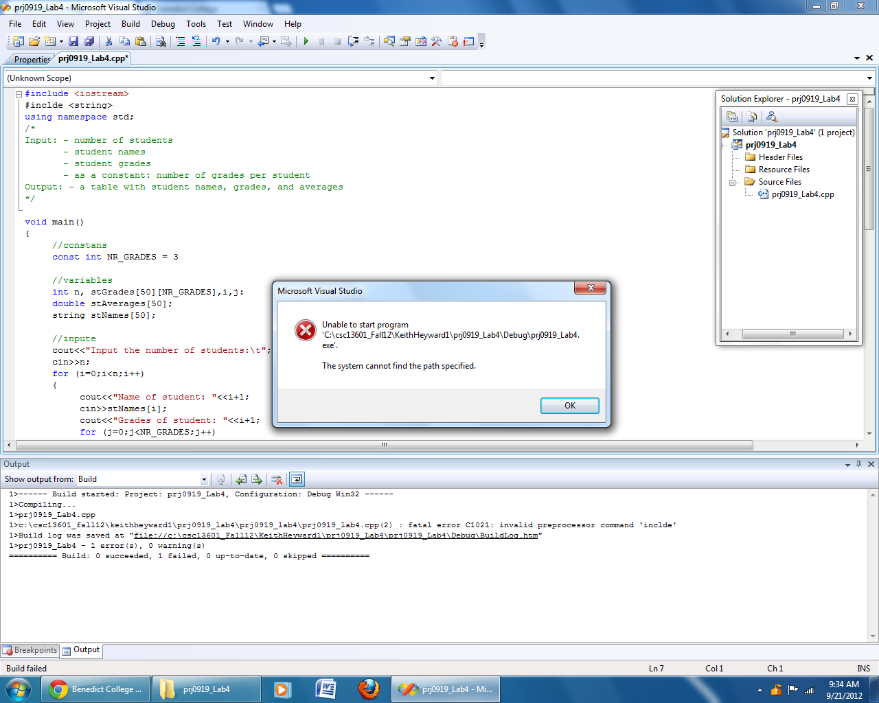
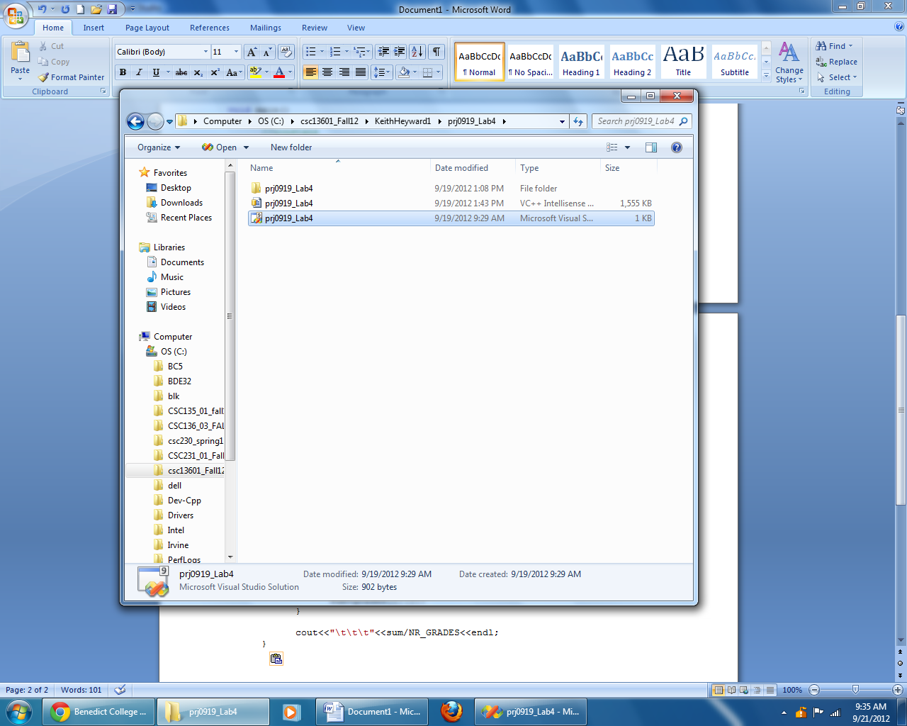

#include<iostream>
#include<string>
using namespace std;
/*
Input: - number of students
- student names
- student grades
- as a constant: number of grades/student
Output: - a table with student names. grades, and averages
*/

void main()
{
//constants
const int NR_GRADES = 3;

//variables
int n, stGrades[50][NR_GRADES],sum,i,j;
double stSverages[50];
string stNames[50];

//input
cout<<"Input the number of students:\t";
cin>>n;
for (i=0;i<n;i++)
{
cout<<"Names of students "<<i+1<<":\t";
cin>>stNames[i];
cout<<"Grades of students "<<i+1<<endl;
for (j=0;j<NR_GRADES;j++)
cin>>stGrades[i][j];

}

cout<endl<<endl<<endl;
cout<<"\tName\t\t\tGrades\t\t\tAverage"<endl<<endl;
for (i = 0; i< n; i++)
{
cout<<"\t"<<names[i]<<"\t";
sum = 0;
for (j=0;j<NR_GRADES;j++)
{
cout<<"\t"<<grades[i][j];
sum+=grades[i][j];
}

cout<<"\t\t\t"<<sum/NR_GRADES<<endl;
}

}

