Katie Ray
Ginger Glodowske
US History 103
June 10, 2020
How the Sinking of the Titanic Impacted World History.
On April 14, 1912 a great ship called the Titanic sank after hitting an iceberg on its maiden voyage. The ship that was known as the “unsinkable” ship was to so many a ticket to a new world and a new life. Carrying a variety of passenger’s, the plan for the Titanic was to start in Southampton, England make scheduled stops in Cherbourg, France and Queenstown, Ireland then finally ending her journey in New York, USA. Tragically the ship sank after 400 miles into the trip. Of the 2,223 passengers and crew only 706 survived. Although the sinking of the Titanic was an enormous tragedy, its legacy still lives on today in many ways. This paper will explain the many ways the sinking of the Titanic changed the way people traveled by implementing new safety regulations, changing how ships were built and also by the forming of the International Ice Patrol organization.
The Titanic was one of the largest passenger ships of its time. With more than 2,200 passengers the boat carried 20 lifeboats which was what was legally required by the Board of Trade Laws, however these laws had not been updated since the Titanic had been built. The International Convention for the Safety of Life at Sea (SOLAS) was established in 1914 because “significant changes needed to be made to the safety and regulations of ships” (Bauman et al.) following the sinking of the Titanic. After a conference in London was held, where attendees from 13 countries were present the following changes were made:
- There must be enough life boats for all passengers and crew
- Passengers would be assigned a lifeboat before the ship sailed to ensure the quickest route to safety
- Four crew members knowledgeable in operating boats would be assigned to each life boat
- Life boat drills would be conducted at least twice a month by the crew
- One life boat was required to have a motorized engine and equipped with supplies such as: a compass, water and food
- Regulations regarding water-tight and fire-proof bulkheads, lifesaving appliances, and fire-fighting appliances on board
(Bauman et al.)
Though so many lives were lost when the Titanic sank many regulations were changed and implemented to ensure the safety of the passengers in future travels at sea.
The way ships were designed and built was another topic that underwent changes following the sinking of the Titanic. Previously, and as they were on the Titanic, the material used to build the ship had high amounts of sulfur which would cause the material to shatter on impact rather than bend, the placement of the rivets that connected the steel plates of the hull were able to be completely scraped off if there was impact to them thus creating large holes, the cold water also made the rivets very brittle. Though there were more flaws in the construction of the ship that were changed, these were some of the major factors. In their revision of shipbuilding regulations SOLAS also implemented these changes:
- Ships should have an interior watertight skin extending above the waterline
- Bulkheads should be spaced so that the flooding of compartments would not tilt the ship
- Watertight transverse bulkheads should extend from one side of the ship to the other connecting to the outside hull on each side
- Transverse bulkheads should reach to the top of the next floor
- All watertight compartments should be able to withstand 5 feet more than the full height of the bulkhead in water pressure without serious damage
- Bulkheads should be tested by being subjected to water pressure, meaning the ship should stay afloat with 2 compartments filled with water
(Bauman et al.)
The sinking of the Titanic gave clear evidence that changes needed to be made to the process of shipbuilding. Since the implementation of these regulations there has not been a shipwreck as severe as the Titanic.
Though there were reports of many casualties of vessels due to icebergs prior to 1912, the sinking of the RMS Titanic was the drive leading to the organizing of the International Ice Patrol by people on both side of the Atlantic. The ship coined as “unsinkable” stood no chance, along with the design flaws, against the estimated 50-100-foot-tall and 200-400ft wide iceberg. (Butler) In 1914 the International Ice Patrol was created and in 1915 the newly organized U.S. Coast Guard assumed charge over the organization. Using their own ships, they would find icebergs and drift with them until they melted while another ship notified the transatlantic shipping community of the location and advise other vessels to keep at a distance while traveling near the area. The organization operated this way until the use of planes was found to be more effective after WW2. (U.S. Coast Guard News) The ice patrol produces North American Ice service reports from February through July when icebergs may be present on the Grand Banks and the Canadian Ice Service produces the reports the rest of the year when icebergs are normally restricted to Canadian coastal waters. (gCaptaings) This is the only location in the world where icebergs endanger a major shipping route, and the ice patrol provides accurate and timely iceberg information to assist transatlantic mariners in avoiding them. (gCaptaings) As recently as 2010, a vessel ignoring the ice patrol’s warnings collided with an iceberg. Fortunately, the damage was not catastrophic and the vessel was able to divert to a safe port. The vessel required considerable hull repairs and was unable to return to sea for some time. No vessel heeding ice patrol’s warnings has ever collided with an iceberg. (gCaptaings)
In September 1985 the wreckage of the Titanic was finally located. Titanic’s wreck is located approximately 370 miles south-south-east off the coast of Newfoundland, lying on a gently sloping plain at a depth of some 12,460ft (3,797m). The ship’s hull lies broken in two main sections. The 450ft bow section is separated some 1,700ft (518m) from that of the 350ft (106m) stern section. (Titanic's legacy) Now the Titanic resides at the bottom of the sea. Many have ventured down to explore and even entertained the idea of raising the mighty ship. After more than 100 years under water there is little doubt the ship would survive being brought to the surface, more importantly many felt this is the final resting place for hundreds of people and to disturb the wreckage would be a huge disrespect to those that lost their lives.
The tragedy of the sinking of the “unsinkable” ship Titanic changed how many of the aspects that helped create the historical ship operated in subsequent years. From the onboard safety regulations, ship building regulations and even the forming of the International Ice Patrol that still operates today, the world certainly a changed environment. The ship and her passenger’s legacy still lives on today as many interested spectators view museums full of recovered artifacts and read the story of the great ship.
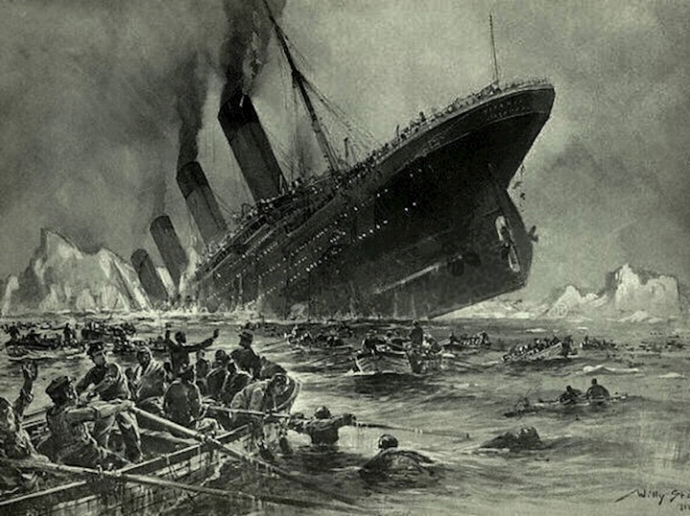
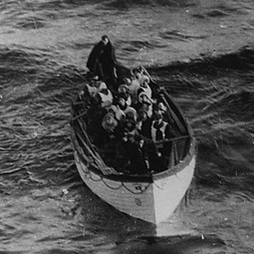
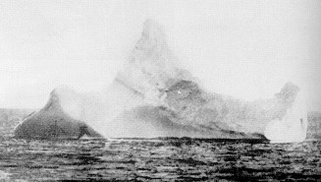
A lifeboat from the Titanic (Bauman et al.) Images of the sinking (Titanic's legacy)
This is a scanned copy of the photographic print of the iceberg with which the RMS TITANIC supposedly collided on April 14, 1912 at latitude 41-46N, longitude 50-14W. (Butler)

Works Cited
Bauman, Anna, et al. “Safety Regulations.” The Titanic, titanicnhd.weebly.com/safety-regulations.html.
Butler, Daniel Allen. 'Unsinkable'. Stackpole, 1998.
U.S. Coast Guard News 04-14-2017 07:51:21, et al. “The History of the International Ice Patrol.” The Maritime Executive, U.S. Coast Guard News, 17 Apr. 2017, www.maritime-executive.com/article/the-history-of-the-international-ice-patrol.
gCaptain, and About gCaptaingCaptain is the top-visited maritime and offshore industry news site in the world. Since 2007. “What Is The International Ice Patrol? And How Ships Avoid Icebergs.” GCaptain, 19 Apr. 2017, gcaptain.com/international-ice-patrol/.
“Titanic's Legacy.” The History Press, www.thehistorypress.co.uk/titanic/titanic-s-legacy/.

